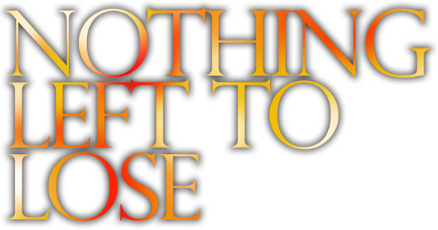
“A theatrical requiem for innocent souls.” Total Theatre
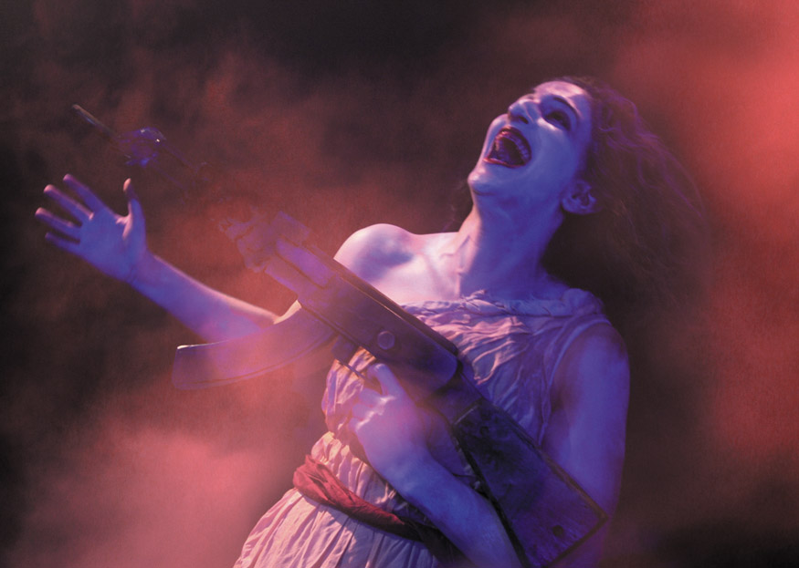

Company:Collisions Production Co.

PO Box 3357 Brighton, BN2 1BB Tel: 01273 710 884 / Mobile: 07932 776114
Email: company.collisions@virgin.net

Nothing Left to Lose

"Company:Collisions knows how to cast a spell and the audience is happy to fall under it." The Stage

In the fearful moments between explosions, a band of battered dolls rises from the wreckage…

Defying defeat they fight for their homeland, forming a resistance against their enemy, armed with little more than sticks and stones.

An eruption of madness, joy, grief and innocence. At the moment when all seems lost they celebrate their final moments together with song and dance.

This delicate tale of a community thrown together through war and absurdity, is brought to you with a sensual fusion inspired by eastern physical theatre, folk dance, clown, puppetry, and acappella singing.

Tracing the dolls’ brave, futile journey from rebellion to extinction, the creators of Frankenstein, La Petite Mort, Medea and Mary hit it again with Nothing Left To Lose.

An ensemble of seven performers, which includes dancers, singers, clowns and actors deliver this high energy, physical production which bristles with startling visuals, bold choreography and original music.
Playful and impassioned in equal measure, Nothing Left To Lose celebrates the enduring spirit of resistance through the ages.

Previous Company Reviews
‘… these performers confounded our expectations, raised and dashed our emotions and ended up totally seducing our minds and hearts.” Deir Yassin Remembered Newsletter
‘Visually and emotionally stunning theatre..’ The Cyprus Mail
‘Company:Collisions knows how to cast a spell and the audience is happy to fall under it.’ The Stage
‘Direction and choreography are simply awesome.’ The Metro

Points of Interest

- The ideas for this show began in 2003 with Company:Collisions’ production of The Constant Tin Soldier, an outdoor show commission by Zap Art for The Streets of Brighton Festival. This show was created as an artistic response to the war in Iraq. Many of the themes discovered in creating this show are taken further in Nothing Left To Lose.
- As a result of The Constant Tin Soldier, the company was invited to do a short piece of theatre on the theme of resistance for The Deir Yassin Remebemerance day at London’s Royal Geographic Society. This was a piece called In The Shadow Of The Wall which was a comedy piece which also served as research for Nothing Left To Lose. This was performed to a predominantly Arab audience which included the ambassador for Palestine. 99% of the audience had not seen a ‘physical theatre’ production like this and it went down a storm!
- The show is about resistance movements. It is an entertaining, colourful, life affirming and moving piece of theatre.
- This show features an ensemble of seven performers, which includes dancers, singers, clowns and actors.
- The language used in the show is completely made up, as the themes of the show are so universal the company have attempted to create a universality in the vocal sound of the play.
- This is also reflected in the music which is a fusion of folk and gypsy music from all over the world.
- It can be described as a piece of ‘physical storytelling’ as the clear narrative is told through action and not words. There is also a lot of singing in the show.
- The creative team includes people from multinational descent including Japanese, Irish, Arabic, Singapore and Romanian. The director, Tanushka Marah who is of Palestinian descent and Ira Sedenstein who is an American Jew argue daily and the rest of the company keep scores! They are planning a street act together…
- Tanushka Marah a previous winner of one of the Young Vic Young Director Awards at the Jerwood.
- The cast features multi-talented artists some of which are also present or past artistic directors of their own theatre companies. They are Ira Sedenstein, aritsitc director of international clown company Chaplin’s eye, Bronwyn Lim, recently directed for Yellow Earth, John Healey, artistic Director of Freelfall physical theatre company, Tanushka Marah, Company:Collisions, Sarah Leaver, co founder of M M, and the company of performers also includes David Kelly, and Liz Griffiths
- The production team includes set designer – Kimie Nakona- (whose credits include working at The Paris Opera, with Ballet Rambert and Peter Greenaway). Music by Andy Frizele ( formerly Kaboodle Theatre Company and The Wizards of Twiddly) and award wining composer Jules Deering. Lighting design by Chris Umney whose credits include designing for the RSC. Luan Blake as assistant director who is the artistic director of Ragroof Theatre and taylor and designer Gael Mailhol on costumes.
- The company trains for at least one hour a day in different methods including Suzuki actor training, Astanga Yoga, Butoh, Voice work and Martha Graham.
- Liverpool’s Hope Street organisation has taken on Company:Collisions as an associate theatre company. The research and development of the show took place in Liverpool for a month.
- This production is funded by The Arts Council England and is the first time the company has received national funding ( as opposed to regional funding).

Review of The Constant Tin Soldier- Total Theatre
At nightfall, under a half moon, in the shadow of St Peter’s Church the expectant crowd approach a bare scaffold stage for Company:Collisions’ commissioned piece ‘The Constant Tin Soldier’. We are not disappointed! In this version of Andersen’s tale, there is no falling from the window into the gutter to be swallowed by a fish – our tin soldier’s treacherous journey is into the cavernous jaws of a more apocalyptic nightmare…
As the clock strikes midnight, the nursery toys come to life – only to be trained for death by a belligerent tutu-clad sergeant major (played with energetic presence by John Healey). Wearing an expression of earnest bewilderment, Sarah Leaver gives a ‘runt of the toy trunk’ tin soldier played with sharp and vital movement. With atmospheric lighting and a soundscape that careers from magical music-box to bleak ambience, Company:Collisions bring us an astute picture of the futility of war. Performed in the constant presence of the aloof ballerina are heart-gripping scenes of the doll army’s pathetic attempt to snap into taut action in the face of battle. Alongside our tin soldier, in victorianesque costume, we have quivering dolls armed with rolling pins, sink plungers, hammers and spoons.
Another memorable choreographic moment is towards the end when the dolls partner empty black suits in a chaotic tumultuous tango. Director Tanushka Marah appears as a ‘Duchess of war’, an imposing menacing memorial to the notion of the glorious death. What is left when her monolithic defiance crumbles?
The production is imaginative in expression and bold in execution. A theatrical requiem for innocent souls. Miriam King, Total Theatre
Previous Company Reviews

Mary of No Man’s Land 2006
A thoroughly human and accessible approach.. Marah is a powehouse of emotions. The Stage

Medea 2004-5
“Visually and emotionally stunning theatre” The Cyprus Mail
“A triumph of emotional conviction…lending great authenticity is the haunting chorus which sings its spine chilling links in Greek….this is a piece of minimalist theatre at its very best.” The Herald “Demanding our unflinching gaze, this beautifully crafted contemporary piece managed to bring the pain of human suffering disturbingly to life.” The Argus
“Bravery…vision…a dynamic performance…infused with a terrific throbbing rhythmic undercurrent…Denise Evans as Medea turned in an exhilarating performance, her sheer commitment to the role lifted the production onto a higher emotional plain.” Southport Visitor

La Petite Mort 2002-3
“A dream-like and moving experience…Company:Collisions knows how to cast a spell and the audience is happy to fall under it.” The Stage
“Director Tanushka Marah pulls no punches in her use of physical and visual metaphor…La Petite Mort captured the essence of Andersen’s tale in its sad beauty.” Total Theatre
“Beautiful and mesmerising…there are some stunning set visuals that stay with you for a long time.” The Argus
“Fascinating…. imagery is everywhere… a riveting piece of theatre” The Chichester Observer
Percolator 2001-2
“A cheery mix of dance and mime…A lovely play on gesture and physical attitude.’ Total Theatre.
Frankenstein 2000-1
“Company:Collisions dynamically blends powerful choreography, high octane music and effects, audio-collage and a well crafted fusion of movement and dialogue…the skilfully energetic cast of four sustains the nightmare of surreal life and death imagery with relentless intensity…A memorable power piece.” The Stage
“Most dramatically charged moments belong to Steve Ryland’s vivid monster, from twitching, gagging, upright birth – to the bitter torment of knowing from whence he came…Mary Shelley shares the stage with her fictional creations in this elaborate, impressive miasma of dance and theatre.” The Scotsman
“You can muse on how art and science share elements of whatever DNA shapes inspiration and creative drive in individuals …Conveys the origins and concerns of Frankenstein to a modern audience in a way that is vivid without resorting to the worst excesses of Hollywood horror-flicks.” The Herald, Critics’ Choice
“Direction and choreography are simply awesome – the audience open–mouthed during the ballet scene involving three hanging bodies…Movement and dance tell some of the story and the wonderful use of lighting, costume and music helps put across many layers of meaning in a most economical way…Physical theatre which is inventive without being pretentious, innovative while remaining accessible.” Metro Scotland

About Company: Collisions
Founded in September 1999, Company:Collisions has been producing theatrical work for the stage and the street as well as teaching in schools, colleges and universities.
The company always works with strong visual imagery, high-energy performances and an intention to create theatre that touches the heart and stimulates the mind. Embracing a diverse collaboration of different art forms, the company works closely with composers, designers and writers to achieve a rich and engaging style of theatre.
The first production, Frankenstein, focused on Mary Shelley’s tragedies in childbirth and her prophesies of latter-day genetic potentialities. With a cast of two women and two men, the story was told through physical theatre and poetry, including the writings of Milton, Nietschze and Rene Char.
La Petite Mort toured nationally and culminated in a sell out run at BAC as part of The London International Mime Festival 2003. An adult adaptation of Hans Christian Andersen’s fairy story, The Little Mermaid, this touching and mesmerising piece was told by four female performers without words.
Percolator is a street theatre production set in café terraces, celebrating café culture through dance and clowning. Co-commissioned by Zap Art and South East Arts this piece continues to tour nationally and internationally.
In 2003, the company devised a street theatre version of La Petite Mort called The Little Mermaid, remaining true to the original tale, this version caters to a wider audience, including the very young. (Commissioned by Zap Art and The Arts Council of Great Britain).
The Constant Tin Soldier was commissioned by Zap Art for The Streets of Brighton Festival 2003 and presented as one of the highlights at night. This adaptation of the Hans Christian Anderson tale is the most political and the largest scale production the company has done to date. A piece about dolls, fate, laughing in the face of disaster and relishing every second of existence. A team of twenty one including twelve performers presented this show to over a thousand people at night-in the rain.
In 2004, the company did its most extensive tour with Medea. Work began on this production when Tanushka Marah received a Young Vic Young Director Award at The Jerwood in 2002. With a cast of six on a bare white stage the company enjoyed working on a classic for the first time, incorporating new skills for the company such as song, text and ancient Greek. This disturbing tale was well received by audience members of all ages over England. It was then invited, in 2005 to Cyprus as part of The International Festival of Ancient Greek Drama to perform in ancient amphitheatres across Cyprus.
Mary, of No Man’s Land is the most recent show which toured in 2004 and 5 and ran in London in 2006. This was a solo show written by Damian Wright which is a secular adaptation of the bible myth about Mary mother of Christ. Company:Collisions has also done several productions with schools and also takes workshops with students in further and higher education.

